**SVPWM SPACE VECTOR PULSE WIDTH MODULATION**

**ABSTRACT:**

Sinusoidal PWM has been a very popular technique used in AC motor control. This relatively unsophisticated method employs a triangular carrier wave modulated by a sine wave and the points of intersection determine the switching points of the power devices in the inverter. However, this method is unable to make full use of the inverter’s supply voltage and the asymmetrical nature of the PWM switching characteristics produces relatively high harmonic distortion in the supply.

**Space Vector PWM (SVPWM)** is a more sophisticated technique for generating a fundamental sine wave that provides a higher voltage to the motor and lower total harmonic distortion (THD). It is also compatible for use in vector control (Field orientation) of AC motors. This abstract describes the theory of SVPWM and the project shall be made using a programmed microcontroller of 8051 family duly interfaced to 3 phase six pulse inverter with 6 no’s MOSFET from DC derived from a single phase mains or 3 phase, 50 Hz supply. The load shall be a three phase 50 Hz 440volt 0.5 HP motor. Alternatively a star lamp load can be used in place of motor to view the waveform only.

Further this project can be enhanced by using IGBT instead of MOSFET for higher voltage power operations. Speed control of the motor can also be achieved by V/F method.

**NOTE:** A **3 phase induction motor of 0.5HP or 1HP is required to see the output. Motor is not supplied along with the kit. However, it can be purchased at extra cost.**

**BLOCK DIAGRAM:**

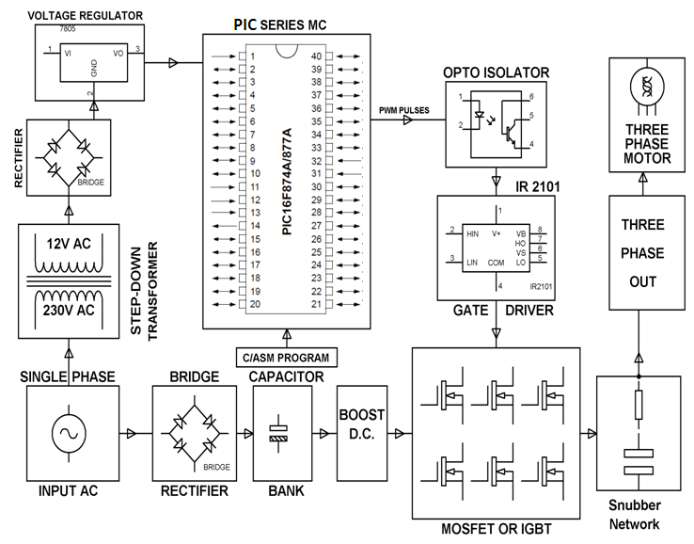

The MOSFET combination in the inverter has eight permissible switching states. Tab. 1 summaries these states along with the corresponding line to neutral voltage applied to the motor.





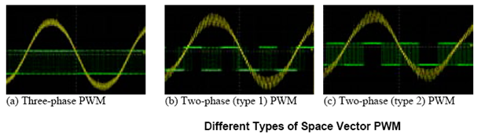

**SOFTWARE REQUIREMENTS:**

HI-TECH PICC Tool suite

Languages: Embedded C or Assembly

**HARDWARE REQUIREMENTS:**

PIC series Microcontroller, MOSFET, Gate Driver, Crystal Oscillator, Toggle Switches, Resistors, Capacitors, Diodes, Transformer, Regulator, Opto-isolators.